ITA0601 – MACHINE LEARNING
LAB EXPERIMENTS
EXP-20: Future Sales Prediction using a suitable machine learning algorithm
Dataset 1 – Sales Prediction
Advertising (₹) | Previous Sales (Units) | Customers | Discount (%) | Sales (Units)
10000 | 100 | 200 | 5 | 120
15000 | 120 | 250 | 5 | 145
20000 | 150 | 300 | 10 | 180
25000 | 180 | 350 | 10 | 215
30000 | 200 | 400 | 10 | 245
35000 | 230 | 450 | 15 | 280
40000 | 250 | 500 | 15 | 310
45000 | 280 | 550 | 15 | 345
50000 | 300 | 600 | 20 | 380
55000 | 330 | 650 | 20 | 415
Python Code:
import pandas as pd
from sklearn.linear_model import LinearRegression
data = {
"Advertising": [10000, 15000, 20000, 25000, 30000,
35000, 40000, 45000, 50000, 55000],
"Previous_Sales": [100, 120, 150, 180, 200,
230, 250, 280, 300, 330],
"Customers": [200, 250, 300, 350, 400,
450, 500, 550, 600, 650],
"Discount": [5, 5, 10, 10, 10,
15, 15, 15, 20, 20],
"Sales": [120, 145, 180, 215, 245,
280, 310, 345, 380, 415]
}
df = pd.DataFrame(data)
X = df[["Advertising", "Previous_Sales",
"Customers", "Discount"]]
y = df["Sales"]
model = LinearRegression()
model.fit(X, y)
new_data = pd.DataFrame({
"Advertising": [60000],
"Previous_Sales": [350],
"Customers": [700],
"Discount": [20]
})
prediction = model.predict(new_data)
print("Dataset 1 - Future Sales Prediction")
print("Predicted Future Sales:",
round(prediction[0], 2), "Units")
Output:
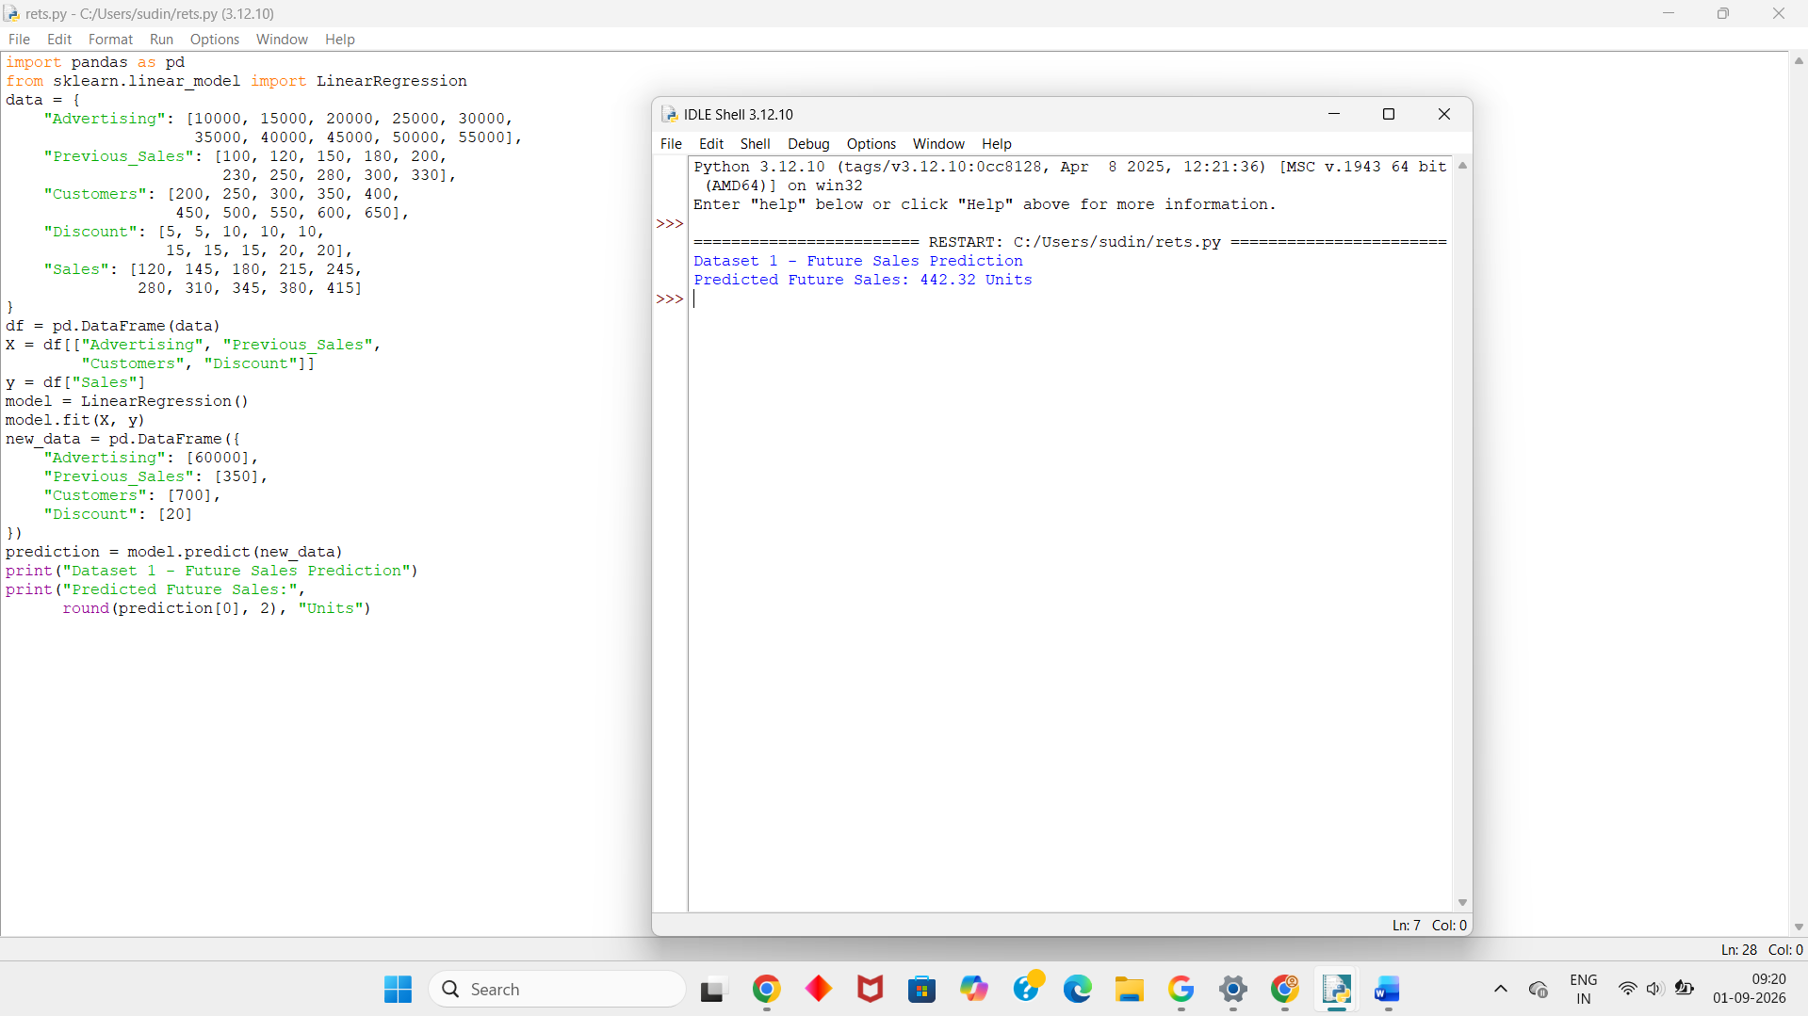
Dataset 2 – Sales Prediction
Advertising (₹) | Previous Sales (Units) | Customers | Discount (%) | Sales (Units)
8000 | 90 | 180 | 5 | 105
12000 | 110 | 220 | 5 | 130
18000 | 140 | 280 | 10 | 165
22000 | 160 | 320 | 10 | 195
28000 | 190 | 380 | 10 | 230
32000 | 220 | 420 | 15 | 265
38000 | 245 | 480 | 15 | 300
42000 | 270 | 520 | 15 | 330
48000 | 295 | 580 | 20 | 365
52000 | 320 | 630 | 20 | 400
Python Code:
import pandas as pd
from sklearn.linear_model import LinearRegression
data = {
"Advertising": [8000, 12000, 18000, 22000, 28000,
32000, 38000, 42000, 48000, 52000],
"Previous_Sales": [90, 110, 140, 160, 190,
220, 245, 270, 295, 320],
"Customers": [180, 220, 280, 320, 380,
420, 480, 520, 580, 630],
"Discount": [5, 5, 10, 10, 10,
15, 15, 15, 20, 20],
"Sales": [105, 130, 165, 195, 230,
265, 300, 330, 365, 400]
}
df = pd.DataFrame(data)
X = df[["Advertising", "Previous_Sales",
"Customers", "Discount"]]
y = df["Sales"]
model = LinearRegression()
model.fit(X, y)
new_data = pd.DataFrame({
"Advertising": [57000],
"Previous_Sales": [340],
"Customers": [680],
"Discount": [20]
})
prediction = model.predict(new_data)
print("Dataset 2 - Future Sales Prediction")
print("Predicted Future Sales:",
round(prediction[0], 2), "Units")
Output:
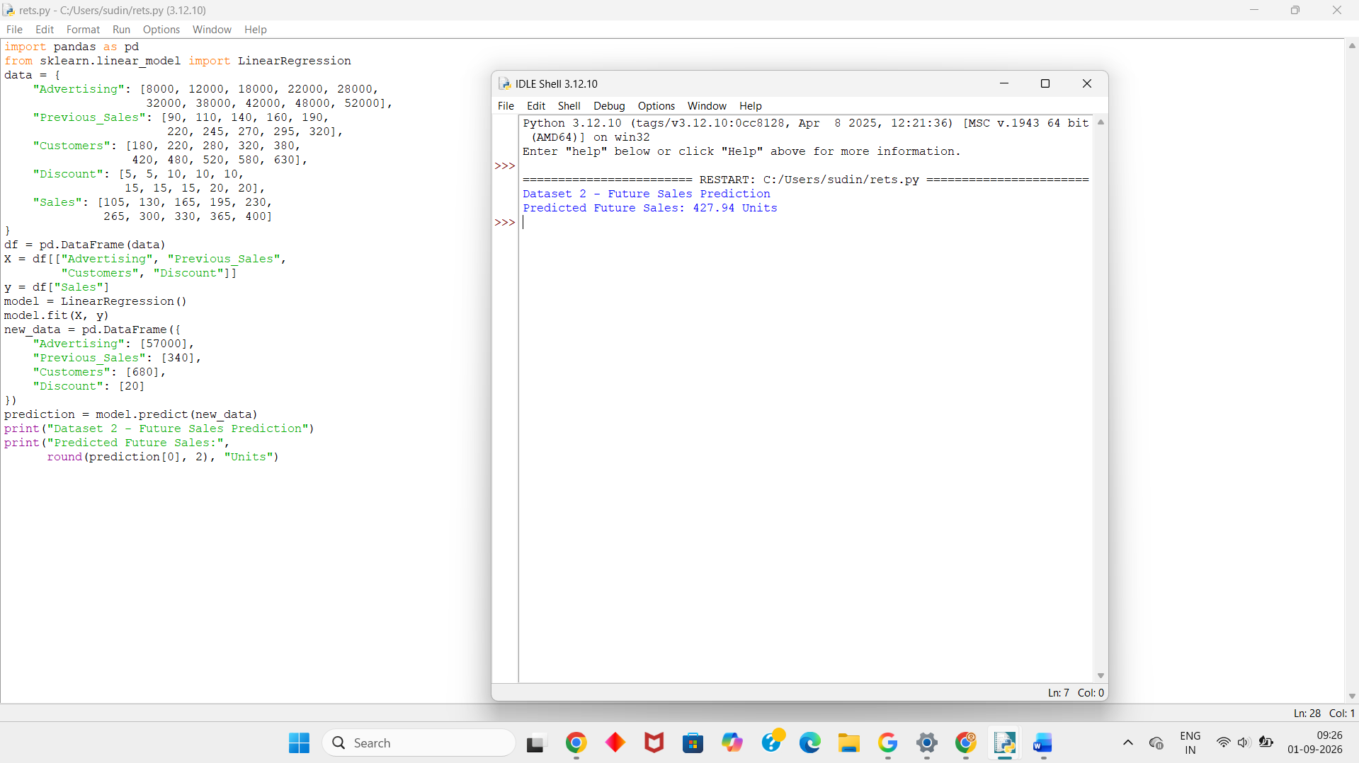
Dataset 3 – Sales Prediction
Advertising (₹) | Previous Sales (Units) | Customers | Discount (%) | Sales (Units)
9000 | 80 | 170 | 5 | 100
14000 | 115 | 230 | 5 | 135
19000 | 135 | 270 | 10 | 160
24000 | 170 | 330 | 10 | 205
29000 | 195 | 390 | 10 | 235
34000 | 225 | 440 | 15 | 270
39000 | 250 | 490 | 15 | 305
44000 | 275 | 540 | 15 | 340
49000 | 305 | 590 | 20 | 375
54000 | 335 | 650 | 20 | 420
Python Code:
import pandas as pd
from sklearn.linear_model import LinearRegression
data = {
"Advertising": [9000, 14000, 19000, 24000, 29000,
34000, 39000, 44000, 49000, 54000],
"Previous_Sales": [80, 115, 135, 170, 195,
225, 250, 275, 305, 335],
"Customers": [170, 230, 270, 330, 390,
440, 490, 540, 590, 650],
"Discount": [5, 5, 10, 10, 10,
15, 15, 15, 20, 20],
"Sales": [100, 135, 160, 205, 235,
270, 305, 340, 375, 420]
}
df = pd.DataFrame(data)
X = df[["Advertising", "Previous_Sales",
"Customers", "Discount"]]
y = df["Sales"]
model = LinearRegression()
model.fit(X, y)
new_data = pd.DataFrame({
"Advertising": [59000],
"Previous_Sales": [360],
"Customers": [700],
"Discount": [20]
})
prediction = model.predict(new_data)
print("Dataset 3 - Future Sales Prediction")
print("Predicted Future Sales:",
round(prediction[0], 2), "Units")
Output:
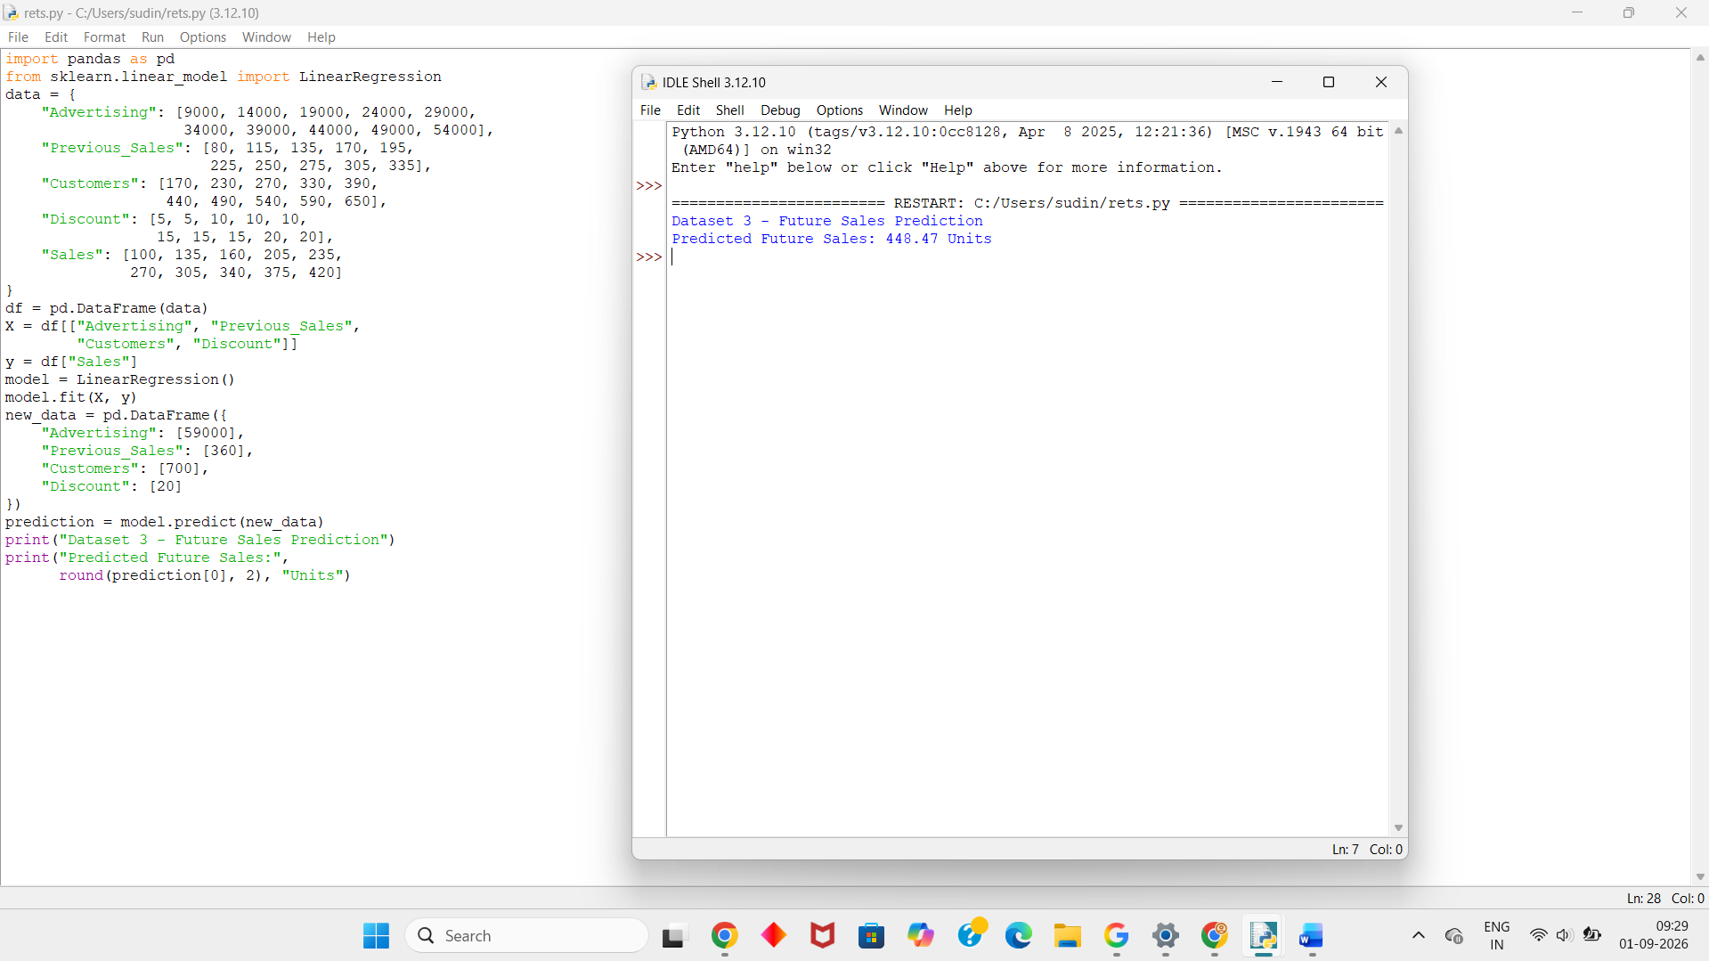
Dataset 4 – Sales Prediction
Advertising (₹) | Previous Sales (Units) | Customers | Discount (%) | Sales (Units)
7000 | 75 | 150 | 5 | 90
11000 | 105 | 210 | 5 | 120
16000 | 130 | 260 | 10 | 150
21000 | 155 | 310 | 10 | 185
27000 | 185 | 370 | 10 | 220
33000 | 215 | 430 | 15 | 255
37000 | 240 | 470 | 15 | 290
43000 | 265 | 530 | 15 | 325
47000 | 290 | 570 | 20 | 355
53000 | 325 | 640 | 20 | 405
Python Code:
import pandas as pd
from sklearn.linear_model import LinearRegression
data = {
"Advertising": [7000, 11000, 16000, 21000, 27000,
33000, 37000, 43000, 47000, 53000],
"Previous_Sales": [75, 105, 130, 155, 185,
215, 240, 265, 290, 325],
"Customers": [150, 210, 260, 310, 370,
430, 470, 530, 570, 640],
"Discount": [5, 5, 10, 10, 10,
15, 15, 15, 20, 20],
"Sales": [90, 120, 150, 185, 220,
255, 290, 325, 355, 405]
}
df = pd.DataFrame(data)
X = df[["Advertising", "Previous_Sales",
"Customers", "Discount"]]
y = df["Sales"]
model = LinearRegression()
model.fit(X, y)
new_data = pd.DataFrame({
"Advertising": [58000],
"Previous_Sales": [345],
"Customers": [680],
"Discount": [20]
})
prediction = model.predict(new_data)
print("Dataset 4 - Future Sales Prediction")
print("Predicted Future Sales:",
round(prediction[0], 2), "Units")
Output:
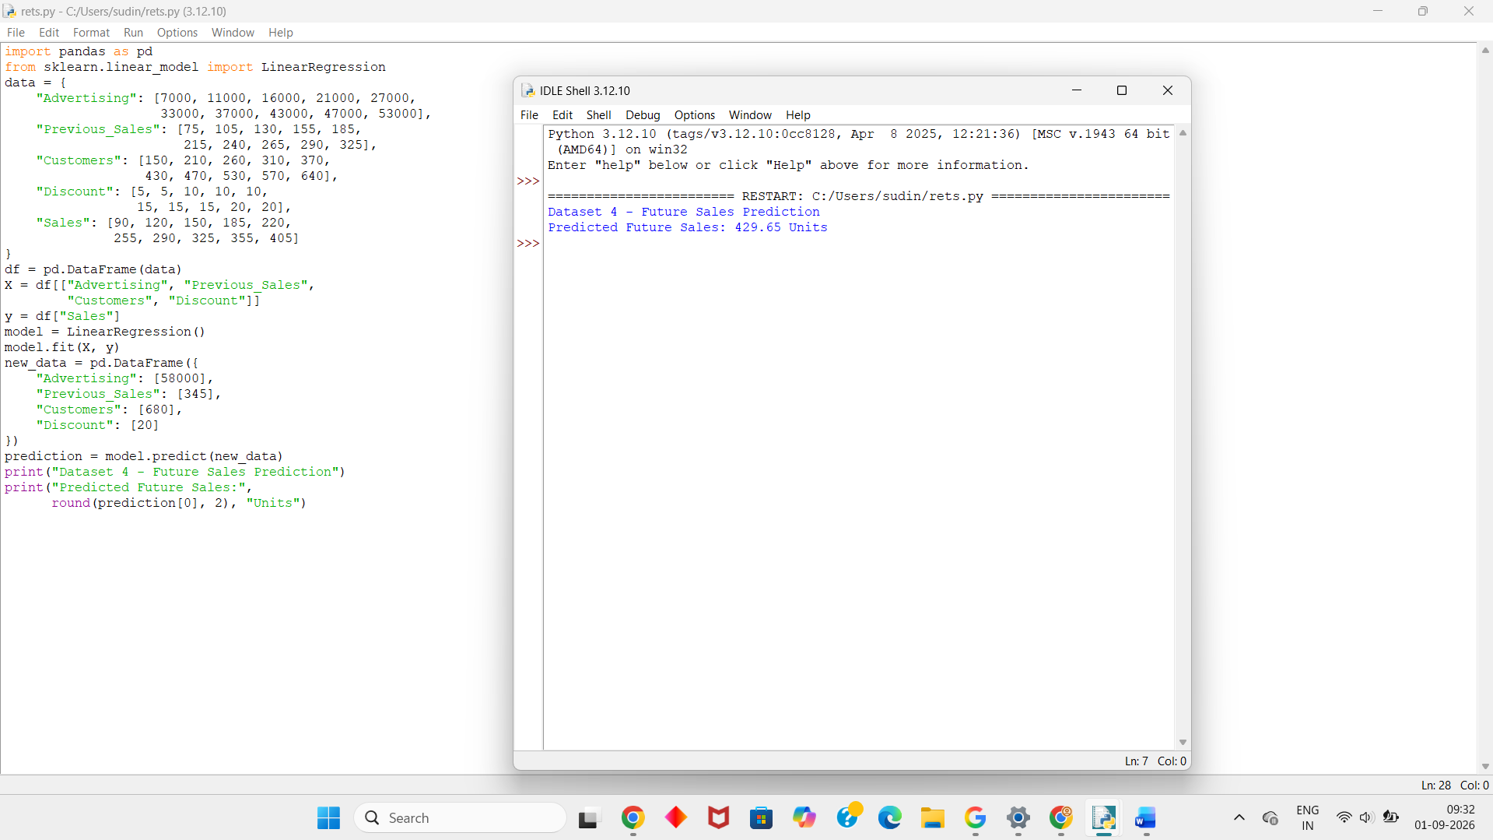
Dataset 5 – Sales Prediction
Advertising (₹) | Previous Sales (Units) | Customers | Discount (%) | Sales (Units)
6000 | 70 | 140 | 5 | 85
10000 | 100 | 200 | 5 | 115
15000 | 125 | 250 | 10 | 145
20000 | 150 | 300 | 10 | 175
26000 | 180 | 360 | 10 | 215
31000 | 210 | 420 | 15 | 250
36000 | 235 | 460 | 15 | 280
41000 | 260 | 510 | 15 | 315
46000 | 285 | 560 | 20 | 350
Python Code:
import pandas as pd
from sklearn.linear_model import LinearRegression
data = {
"Advertising": [6000, 10000, 15000, 20000, 26000,
31000, 36000, 41000, 46000, 51000],
"Previous_Sales": [70, 100, 125, 150, 180,
210, 235, 260, 285, 315],
"Customers": [140, 200, 250, 300, 360,
420, 460, 510, 560, 620],
"Discount": [5, 5, 10, 10, 10,
15, 15, 15, 20, 20],
"Sales": [85, 115, 145, 175, 215,
250, 280, 315, 350, 395]
}
df = pd.DataFrame(data)
X = df[["Advertising", "Previous_Sales",
"Customers", "Discount"]]
y = df["Sales"]
model = LinearRegression()
model.fit(X, y)
new_data = pd.DataFrame({
"Advertising": [56000],
"Previous_Sales": [335],
"Customers": [670],
"Discount": [20]
})
prediction = model.predict(new_data)
print("Dataset 5 - Future Sales Prediction")
print("Predicted Future Sales:",
round(prediction[0], 2), "Units")
Output:
